It is observed company is holding huge free cash flow (FCF). It signals that Oracle company is reserve to pay debt, pay dividends, buy back stock and facilitate the growth of business all important undertakings from an investor's perspective.
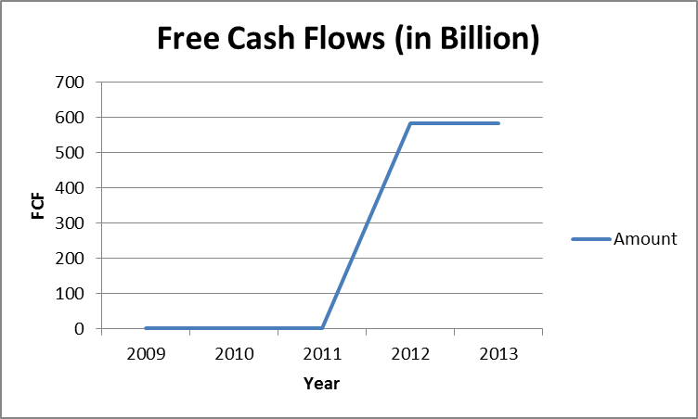
On many occasions company opted for 2-to-1 and 3-to-2 common stock split. It can be a strategic decision in order to boost its share price. As seen from the chart below sharp change in price per share, apart from company’s good performance, can be because of stock split.

